SMTP Server for Testing Purpose

Under:  [\\FSERVER\sharedPG\SMTP4Dev\](file:///\\FSERVER\sharedPG\SMTP4Dev\)

When launch the application will run “minimize” in the notification area…

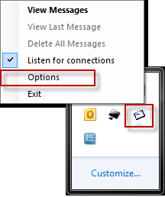

Right-Click and Select “Option”

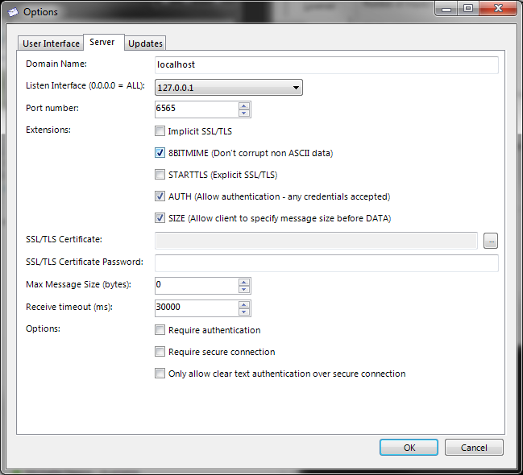

In GovAdmin or GNA

